Functional Requirements Specification

Projet Intelligence Artificielle

Sommaire
Functional Requirements Specification 1
For [Application project] XXX 1
Document Releases 2
Table of content 3
1 Context 4
1.1 Project Context 4
1.2 User Characteristics 4
2 Reference Documents & Terminology 5
2.1 Technical Reference Documents 5
2.2 Financial Reference Documents 5
FIRST PART USE CASES 6
3 Use Cases Description 7
3.1 Actors Description 7
3.2 High Level Scenarios 8
3.2.1 Use-Case List 8
3.2.2 Use-Cases Description 9
3.3 Detailed Complementary Scenarios 10
3.3.1 Use-Case List 10
3.3.2 Use-Cases Description 11
SECOND PART PRODUCT REQUIREMENTS 13
4 Requirements Description 14
4.1 Conventions 15
4.2 Some Examples of FRS IDs 17
4.3 18
4.4 18
4.5 Functional Requirements 18
4.6 Performance requirements 18
4.7 High Availability (HA) and Quality of Service (QoS) 19
4.7.1 High availability requirements 19
4.7.2 High availability metrics 20
4.7.1 QoS metrics 20
4.8 Interface Requirements 21
4.9 Industrial Requirements 21
4.10 Design / Implementation Requirements 21
4.11 Installation Software Requirements 22
4.12 Attributes: Usability, Reliability, Supportability 22
THIRD PART PRODUCT DEPLOYMENT 24
5 Customer Market Constraints 25
5.1 Development Milestones 25
5.2 Industrial Milestones 25
6 Packaging and Deliverables 26
7 Support and Training 27
8 Project Management Requirements 28
FOURTH PART TRACEABILITY of USE CASES versus REQUIREMENTS 29
9 Traceability Matrix 30

Contexte

Contexte du projet
Ce projet s’inscrit au sein d’un projet d’intelligence artificielle se déroulant au cours de l’été 2011. L’objet de celui-ci est de créer un moteur de simulation afin de répondre à une problématique sélectionnée par les différents groupes.

Dans notre cas, nous avons décidé de développer un logiciel de simulation de consommation énergétique d’une habitation ainsi que le gain que peut apporter des panneaux solaires sur celle-ci.

Caractéristiques utilisateurs
L’utilisateur est imaginé comme un commercial, vendeur de panneaux solaires qui se sert de ce logiciel afin de convaincre ses prospects d’installer des panneaux sur leur toit.

L’utilisateur n’a donc aucunes compétences techniques et doit bénéficier d’une interface intuitive afin que sa démonstration se déroule au mieux. De plus, afin de convaincre de possibles futurs clients, il est nécessaire d’avoir une interface agréable qui soit vendeuse.

PREMIERE PARTIE
CAS D’UTILISATION

Description des cas d’utilisations

Description des acteurs

Acteur | Description
Utilisateur | L’utilisateur est un commercial qui va manipuler le logiciel. Il n’a aucune compétences techniques et doit bénéficier d’une interface intuitive afin de ne pas être perturbé lors de sa démonstration
Prospect | Le prospect est un spectateur plus qu’un acteur. Il n’a aucune influence sur le déroulement du programme mais il doit être convaincu par le logiciel afin de possiblement s’équiper de panneaux solaires

Scénarios

Liste des Cas d’utilisation
Identifiant | Titre

Description des cas d’utilisation
Title of this Use-Case
Identifiant | Unique identifier of this Use-Case (used for traceability)  UC_NNN  NNN: Number between 001 and 999 (whatever the category)
Description | Short description of what this Use-Case is about
Diagramme | Diagram describing the main components of the system participating to this Use-Case and how they interact with each other
Acteurs | List of all actors involved in the flows of events described in this Use-Case
Déroulement
Etapes | 1 | Actor | First step which triggers the flow of events described here
Etapes | 2… | Actor | Next steps of this flow of events (to add a new step, select the cells: step number, actor and description, open the “Table” menu, then the “Insert” submenu, and click on “Rows Below”)
Etapes | n | Actor | Final step which terminates the flow of events described here

SECONDE PARTIE
EXIGENCES

Requirements Description

For generating requirement label, use the < CTRL+ ALT + R > keyboard keys
To modify existing requirement label, use the < CTRL + ALT + M > keyboard keys

Rules for requirement specification
The statement must be written in a very simple sentence. The statement should not require more than 2 lines, otherwise it is likely that it expresses more than one requirement. Use the simplest words appropriate to the intent of the statement.
Avoid fuzzy words that have relative meanings such as "easy", "normal", "adequate", or "effective". Do not use generalities where numbers are really required such as "large", "rapid", "many", "timely", "most", or "close".
Do not use words or terms that give the provider an option on the extent that the requirement is to be satisfied such as "may", "if required", "as appropriate", "optionally", or "if practical".
Avoid weak phrases that are apt to cause uncertainty and leave room for multiple interpretations. Use of phrases such as "adequate" and "as appropriate" indicate that what is required is either defined elsewhere or, worse, that the requirement is open to subjective interpretation. Phrases such as "but not limited to" and "as a minimum" provide a basis for expanding a requirement or adding future requirements. A weak phrase found in a document is an indication that the specification is ambiguous and incomplete. Avoid them bellow a non-exhaustive list: adequate, as a minimum, as applicable, easy, as appropriate, be able to, be capable, but not limited to, capability of, effective, if practical

In order to make the list of requirements clear, they have been divided into several categories. Although it may be difficult sometimes to attach a requirement to such category, the most important is the presence of the requirement in the list whatever the category it belongs to. Of course, all the categories are not mandatory; feel free to remove some of them. In the following pages, when possible, 2 examples of requirements have been given for each category: a "card-oriented" requirement and a "OTA-oriented" requirement.
A requirement must always follow the syntax : [Item specified] [Specification verb] [Specification attribute] where:
[Item specified] Clearly and unambiguously identify the item a requirement is associated with.
[Specification verb] It is preferably a verb in the present tense. The use of should, may or shall is too
difficult to express unambiguously an essential or conditional requirement; therefore, another meaning will be proposed below to express this ranking.
[Specification attribute] Is the association of a quantifiable and verifiable specification attribute.

When referring to a technical specification (standard, customer specification), a requirement must only mention the title of the document and/or the corresponding “index”; the reference of the document or specification must be defined in the chapter “Reference document”. Use the document identifier when referencing information in the Reference document chapter. For example: “as defined in the 11.14 standard [Ref1]”.

The use of the TBD (To Be Defined) is occasionally necessary and should be followed by a description of the condition causing the TBD (for example, why an answer is not known), so that situation can be solved, a description of what must be done to eliminate the TDB, who is responsible for its elimination, and when it is must eliminated. This status shall be reported on the first page of the document.
When an example is provided, ensure that it is not mistaken as part of the specification by the use of italics, quotes, or being explicit. For example: "This is an example". Immediately follows what is to be illustrated with the example.
When using tables and charts, identify the purpose of the table or chart in the text immediately preceding it.

Conventions
All requirements are identified with the following syntax:

F#_ NNNN[_T][_O]_R,

Convention can be viewed through <CTRL + ALT+ R> command

Where :
- NNNN: Requirement number [Mandatory]
The Macro manage an automatic numbering for the Document so that
All requirements must have a unique requirement number whatever the requirement type:
- First requirement number: 0001
- New requirement number = biggest requirement number + 1 (whatever the requirement type)
- In case of deletion, the requirement number is never re-used.

- T: Requirement Type [Non Mandatory]
  - F-Functional requirement
  - C-Customer Market constraint
  - D-Design requirement
  - S-Security requirement
  - G-Graphical interface requirement
  - I-Interface requirement
  - M-Project Management requirement
  - O-Capacity and perfOrmance requirement
  - P-Packaging and Deliverables requirement
  - Q-Quality requirement
  - S-Installation Software requirement
  - T-IndusTrial requirement
  - S-Support and training requirement
  - Y-DeploYment requirement

- O: Requirement origin [Non mandatory]
  - C-Customer Requirement
  - G-Gemalto Requirment
  - T-3rd ParTy Requirment
  - S-Standards Requirement

- R: Ranking class of the requirement [Mandatory]
C Conditional
E Essential

Essential (Requirement)
Means that the software product will not be acceptable unless these requirements are provided in an agreed manner.
Conditional (Requirement)
Means that these requirements would enhance the software product, but would not make it unacceptable if they were absent. You had to give a priority level to each individual conditional requirement in the “”.

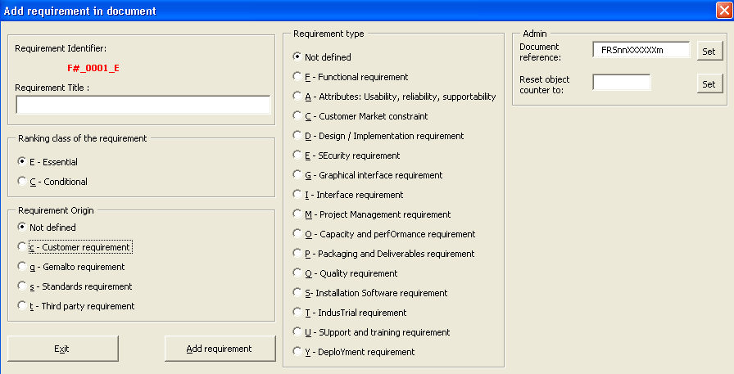

Modifying a Requirement will add the “_CR” suffix to this requirement.

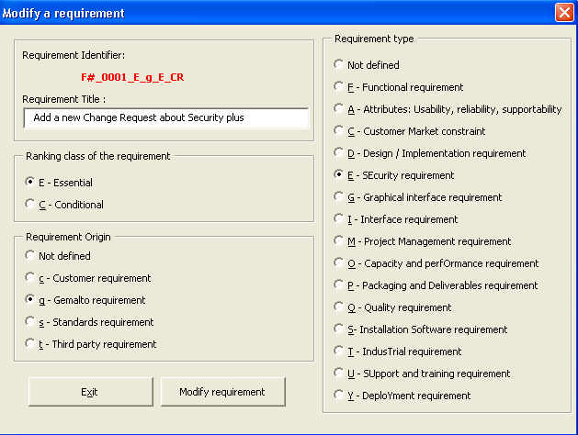

Some Examples of FRS IDs

[Guideline : Define requirement about product usability. may include human factors, aesthetics, consistency in the user interface, and user documentation and training materials. Examples are:Functional Requirements
[Guideline : Define requirements that specify a function that the product must be able to perform as
- required service or
- expected performances (speed, response time, recovery time) with acceptance criteria.
- possible expected attributes (security, efficiency, availability, accuracy) with acceptance criteria.
- required set of tests (ex: test suite).
- compatibility with existing products.

F#_0065_F_E The platform shall reach the following performance for OTA services, number of OTA messages handled :

 |  | # SMS MT ₁ | # SMS MO ₁ | # SMS MT _{n}
 | Market needs | 25 | 8 | 200
 | Expected performance | 12 | 8 | 150
F#_0066_F_C The number of broadcast XDS / hour shall be reported daily to Supervisor level.

F#_0067_D_E Tests on Mobile Equipment are performed on Philips XX, Nokia YY, Motorola ZZ (exact reference).

Specific requirements for GSM
As a minimum, this section shall identify requirements from GSM standards and give an exhaustive list of
non selected items :
- administrative commands,
- GSM commands,
- SIM Toolkit proactive commands,
- Operating System mechanisms,
- OTA communication,
- Algorithms & Security,
- Data structure.
This detail compatibility with existing products and other standards.
]

Performance requirements
[Guideline: Define requirements qualifying the performance of the service delivered by the product/solution. Detail here for instance the nominal traffic, the time window when to support this nominal traffic, peak to be supported , peak duration and way to handle the peak.

F#_0008_F_E Nominal traffic/flow rate: Server must support service traffic lower or equals to 10 transactions per second for the use case .<service installation in selfcare mode> defined above.
To achieve this traffic, the environment to take into consideration is:
- Hardware X, Rack Y, Disk storage W etc… as defined in the Hardware catalogue.
- Customer Interfaces context
  - Coverage rate: 95% of SMS reached the MSISDN targeted during the installation process
  - Response times: SMS are delivered in X seconds and related Delivery Status is received in Y seconds./
  - other external interfaces like partner solution components should be defined here.
- Volumetry: Subscriber base is between 1 and 5 Millions of subscribers.
- High Availability context defined below.

Nominal traffic time window: The standard traffic to be supported is applicable from 6:00 AM to 10 PM. Then traffic of 1 installation per second must be supported during the rest of the time.

F#0013_F_E Peaks of 30 installations per second must be supported during standard traffic.
Peak duration shall not exceed 1 hour. Service request exceeding nominal traffic must be postponed for a later treatment by the server and will not be lost. 2 peaks should not occur more than twice in 24h separated by 2 hours of normal traffic in-between.
]

High Availability (HA) and Quality of Service (QoS)
[Applicable for software solutions only.
Guideline: Define requirements enabling Gemalto to commit on a given HA level with our customers (bearing in mind product evolutions don’t make alone the HA level). These requirements deal with continuity of service, SLA monitoring, performance in degraded modes, recovery objectives in case of crash.

For all use cases defined in chapter 2, ensure that you have defined the following use cases characteristics:
- Triggering channel: For instance selfcare on the web, selfcare on the handset, or campaign mode.
- External interfaces: For instance SMSC, Intelligent network, etc…
- Service Usage time frame: For instance 24 by 7 service availability.

High availability requirements
List here HA requirements (HA Class: UHA, VHA, HA, NC HA), Recovery Point Objectives (RPO), & Recovery Time Objectives (RTO). Each requirement can be applicable for only one or many use cases.

F#_0019_F_E HA class targeted for the solution in campaign mode for use case < service installation in campaign mode > is: VHA = 99.99%.

F#_0029_F_E HA class targeted for the solution in selfcare mode for use case < service installation in selfcare mode > is: HA = 99.9%.

F#_0028_F_E RPO: In case of one node failure and for use case < service installation in selfcare mode >, no more than 10 transactions should be lost.

F#_0038_F_E RTO: In case of one node failure and for use case < service installation in selfcare mode >, the service shall be restored in nominal mode within 15 minutes.

F#_0035_F_E RPO: In case of one node failure and for use case < service installation in campaign mode > . It shall be possible to replay the campaign scenario for the targets from initial target list that were not succeeded at the time of crash.

F#_0041_F_E RTO: In case of one node failure and for use case < service installation in campaign mode it shall be possible to re-launch manually the campaign within 5 minutes .

High availability metrics
List here requirements regarding HA metrics that will help you to follow our HA commitment.

F#_0042_F_E A probe independent from the main software module will track a fake Over the Air installation service. This fake service is based on a fake subscription that will follow the same flow as any installation transaction in the product except that last action: SMS sending will not be performed on the real customer SMSC but routed to a specific module that will reply a positive answser . Service to install will be a small service leading to a 1 SMS sending. This probe will be used to measure our SLA Commitment.

F#_0043_F_E A probe will trace the response time of the SMSC, a fake request authorized by the MNO will allow us to measure the availability of the SMSC. This probe will help us to justify external system non availability or QoS issue in case Gemalto solution slows down or is stopped.

QoS metrics
List here requirements regarding QoS of our solution.

F#_0044_F_E A statistic will compute the number of errors in service installation. This statistic will be computed every hour. An alert will be launched in case of overflow of a configurable threshold.

F#_0045_F_E A statistic will compute off line the average duration of all installation transactions performed in Gemalto product scope. This statistic will be available every day and compute outside the normal traffic flow i.e. between 10 PM and 6 AM.

]

Interface Requirements
[Guideline : Define requirements that specify an external item with which the product must interact or that sets out constraints on formats, timings or other factors caused by such an interaction.

F#_0006_F_E The T=1 supports a speed of 115 KBd with an external clock at 3,5759 MHz.

F#_0004_D_C The card software product supports the T=1 protocol according to the ISO standard [ref 1].

F#_0005_D_C The product must interact with a printer XXYY ref zzzz using the serial port.

]

Industrial Requirements
[Guideline : Define requirements which take industrial constraints into account.
Indicate which data or operations carried out at the end of the production cycle will be used to customize the product for the customer application.
Describe the technical characteristics of the personalization / initialization procedure; what documents serve as the reference for personalization (for Smart Card).

F#_0001_F_E The personalization step needs to support the T=G protocol

F#_0002_F_C The personalization step takes less than 2 s

]

Design / Implementation Requirements
[Guideline : Note : a design requirement is often called a design constraint

List in this section imperative Customer or Gemalto design requirements. Examples are:
- targeted platforms (ex: various chips, computers, test equipment),
- product resources (ex: free memory size, residual power)

F#_0003_D_E HP L2000 and N4000 for HP-UX are the targeted platforms.

F#_0007_D_C E4500 for Sun Solaris are extra targeted platforms.

F#_0023_D_E The card software product contains the B0’ applet in ROM, applet loading shall be performed in accordance with CB Security requirement [Ref 12].

An implementation requirement specifies or constrains the coding or construction of a system. Examples are:
- required standards,
- implementation languages,
- policies for database integrity.

F#_0008_D_C Required implementation languages is visual C++ release 9.8.

Give the list of main patents (internal and external) involving this product, which impact on design.

F#_0019_D_E Data Base embedded into Smart Card shall use Gemalto patent [Ref14]

Identify export constraints (ex: algorithms, key length) which impact on design.

F#_0043_D_E 3DES algorithm with Key 1024 length is loaded as an applet. Only for Extended Power Card

]

Installation Software Requirements
[Guideline : In this part, we describe what are the requirements to define the features of the installation software of the product.

The features of the installation software could be in term of :
- Product name and version.
- Type of media support to deliver product release, upgrade or service package.
- Product installation strategy or scenario.
- Legal aspect.
- Platform.
- Hardware material.
- Gemalto or non Gemalto software which must be installed prior to the installation of the product.
- Language:
Indicate languages that the installation software must support and propose to the end-user.
- Autorun:
If an AutoRun mechanism is required, indicate how it should work.
- Security and registration Indicate:
If the product needs registration or control mechanism in order to be installed. For example, serial number, online registration, hardware dongle.
]

Attributes: Usability, Reliability, Supportability
[Guideline : Define requirement about product usability. may include human factors, aesthetics, consistency in the user interface, and user documentation and training materials. Examples are:
- specify the required training time for normal users and power users to become proficient at particular operations,
- specify measurable task times for typical tasks,
- specify basic usability requirements of the new system or other systems that the users know and like,
- specify requirements to conform with common usability standards (eg. GUI standards published by Microsoft for Windows 95).

F#_0055_D_C Abort, Pause, Print a Report, Give a Status features shall be the same throughout software activation.

F#_0037_D_E The performance 10⁶ of read/write cycle is expected.

Define requirement about product supportability may include testability, maintainability, compatibility, configurability, or localizability (internationalization).
This should specify attributes of software that relate to the ease of maintenance of software itself.

For instance describe measures that will allow later product upgrades (additional memory, standby mechanism, entry points for new commands, provision for future features), perspectives for upgrade of components or materials to obtain higher performance (new generation chip, stronger / cheaper materials, better antenna performance),

F#_0024_F_E The self-test activation is provided by a single supervisor command and return value of Authenticate Counter and Balance B data.

F#_0025_D_E All libraries concerning supported chip shall be downloadable

F#_0026_F_C Installation process shall be done in under 15mn by a typical user (see typical skill below).

F#_0030_F_E Software will be used on Asian computers, Chinese characters shall be supported.

THIRD PART
PRODUCT DEPLOYMENT

Customer Market Constraints

Development Milestones
[Guideline : Give at least the forecast of date the Validation review and, if required by the Market, the delivery date(s) of different beta release (defined the functional perimeter and the validation level of the delivery) requested.

Nature & scope Milestones | Comment & scope | Dates of
Beta release availability | Pki non implemented in order to run load test on field (communication issue) | 15 November 2001
Validation review | Complete release of the product (non Visa certified) | 20 January 2002

Industrial Milestones
[Guideline Give the forecast of dates of committed Milestones, at least these milestones are :
- First Customer delivery *¹,
- Full Release Granted *².

Nature & scope Milestones | Comment & scope | Dates of
Beta release availability | Pki non implemented in order to run load test on field (communication issue) | 15 November 2001
Validation review | Complete release of the product (non Visa certified) | 20 January 2002
Fist Customer delivery | ZKT Customer | 4 April 2002

*¹ First Customer delivery is dependent on date of first Customer order, commitment could be fix as T0 + X months.
*² Full Release Granted is still dependent on Customer orders and volume of card manufactured, commitment could be fix as concurrent drawing of 500 Ku card made.

Packaging and Deliverables
[Guideline Describe the packaging of the end-product such as the documentation (number of copy, language) and CDRom.

Define terms that shall be fulfilled before any delivery.

Define for known bug list :
- medium (ex: paper, magnetic),
- how place this list at Customer’s disposal,
- what is frequency of update.

Define for service pack :
- how distribute them,
- how bring them into operation (cumulative or not, reversible or not).

Give the complete list of other support documents, in particular those defining configuration constraints of external equipment (or product) connected to the product.
Give the complete list of tools/libraries for other Gemalto products or applications.]
]

Support and Training
[Guideline Give the policy for moving previous release(s) to the actual one. What are the release(s) still supported, obsolescent releases (which will not be supported from the next release) and obsolete one (which will not be supported from now).

Define maintenance policy, in particular :
- maintenance grades,
- necessary resources and means for maintenance operations,
- lead time to react, break time for recovering.

Specify the representative configuration of target platform (“End to end”).

List in this section all required training, specify an availability date and a number of session per year :
- internal training (Technical Consultants, Marketing) about product,
- internal training about training support (ex: Hot line, Maintenance Team),
- external training for Customers and Value Added Reseller.]

Project Management Requirements
[Guideline If relevant define progress meeting required (ex: frequency, attendees, report form).

If relevant, refer the quality requirements (ex: audit, intermediary check) to Customer(s) and give the resulting activities (refer to a document or describe in a table inside this section).]

